A Celebration and Groundbreaking
December 10, 2017
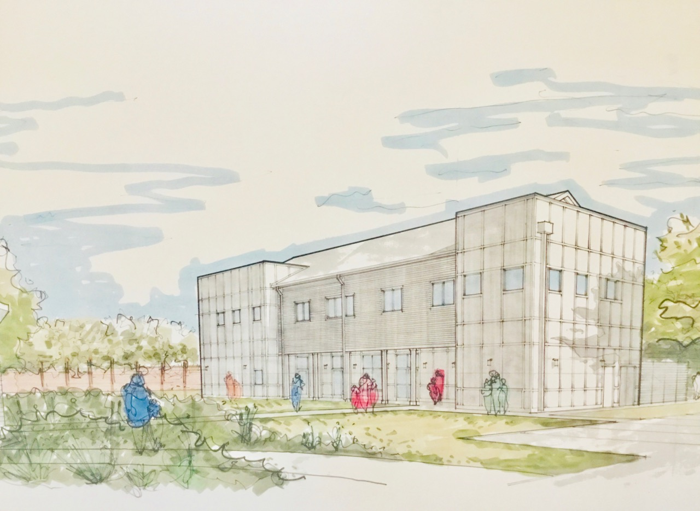

Covenant Singers Anton Bruckner
“Locus iste a Deo factus es”
This place was made by God a priceless mystery; it is blessed.

Responsive Blessing for Breaking Ground
Leader: In Exodus, we read of Moses who, while tending the flocks, saw the Lord in a flame of fire out of a bush. The bush was blazing yet it was not consumed. From out of the bush, God called to Moses:

People: “Come no closer! Remove the sandals from your feet, for the place on which you are standing is holy ground. I am the God of your ancestors, the God of Abraham and Sarah, the God of Isaac and Rebecca, and the God of Jacob, Leah, and Rachel.”

Leader: We are standing on holy ground. If we have eyes to see, every bush is aflame with God’s presence.

People: Let us look again. Let us see this ground beneath our feet, let us see each other, let us know again the divine presence in and among us. The ground of our hope is present this day, in this place, with each of us.

Leader: This is the ground on which we will build space for community, for justice work, for teaching and learning. We give thanks for those gathered and for the many who have come before us. We feel the presence of those who have made Covenant together for five decades. We are especially thankful for those who made the purchase of this land possible, for those who did the work of building, and for those, in this season of our church, who have made and continue to make this expansion possible.

People: This ground is holy. As our plans and visions begin to take shape on this ground, fill us with compassion and love, fill us, Holy One, with your presence. We give thanks for the many who have worked so hard for this day. We give thanks for our Covenant community. This day is the fruition of our collective efforts of vision and resources.

Leader: We will break ground this day with a shovel and in the coming week the heavy equipment will begin its work. As we build, we promise to use this new space with purpose. As we watch this expansion of our building come into reality, may we never lose sight of our mission to inspire, act and care for each other and for the wider community in which we live.

People: Standing here together, on the cusp of the fulfilment of our years of planning, we pray that we will look with gratitude on the progress of our expansion, grateful for those who have given us the foundation upon which to continue our covenant together. On this holy ground we will continue our work for justice and peace, our work of ever expanding welcome, our work of hope for the world. Amen

Groundbreaking

“God of Grace and God of Glory”
God of grace and God of glory, on Thy people pour Thy power;
Crown Thine ancient church’s story; bring its bud to glorious flower.
Grant us wisdom, grant us courage, for the facing of this hour,
For the facing of this hour.

Set our feet on lofty places; gird our lives that they may be
Armored with all Christ-like graces, pledged to set all captives free.
Grant us wisdom, grant us courage, that we fail not them nor Thee!
That we fail not them nor Thee!

